# Excel Tutorial

## 01- Excel Shortcut Keys

### 1.1- Table

Ctrl + T

Used to manage and filter data

If you select “No” you will have transposed table design

### 1.2- Total Row

Ctrl + Shift + T

### 1.3- Adjust Table (Macro)

Ctrl + H

### 1.4- Un-List Table

Ctrl + J

### 1.5- Transpose Table

Ctrl + Shift + V

You can’t transpose an entire table unless it’s only values

Un-list it first then transpose

Otherwise:

To transpose a table, ctrl + A on it’s body and transpose that

Then ctrl + shift + right on the headers and transpose that separately

## 02- Chart Guide

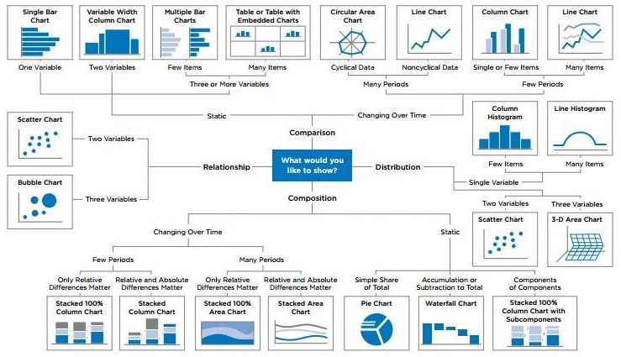

## 03- Pivot Tables (for Summary)

https://fiveminutelessons.com/learn-microsoft-excel/how-create-pivot-table-excel

OLAP = Online Analytical Processing

Excel does this using Pivot Tables

It allows you to select what data you want to see and summarize your data

### 3.1- Grouping

Data Tab -> SubTotal -> Choose shit

### 3.2- Sorting

If i want to know my best sales rep in each region

Home -> Sort & Filter -> Custom Sort ->

### 3.3- New Notes

Pivot Table

-> Date Max and Date and Sales in the lower right box

Copy it and put it in another excel because it makes errors sorting on pivot table

Sort the shit

## 04- SUMIF/SUMIFS

## 05- COUNTIF / COUNTIFS

## 06- Data Filters

## 07- Data Sorting

## 08- Cell Formatting

## 09- Data Validation

## 10- Workbook

## 11- Managing Page Layout

## 12- Charts & Its Analysis